The objective was to create a system capable of streaming live weather data for two Canadian cities, Winnipeg and Vancouver, and persisting this data into a PostgreSQL database. The python scripts are developed for Kafka producer and consumer, along with auxiliary functions for data generation and database interaction.

Services:
- Zookeeper and Kafka Servers:
  - Both the Zookeeper and Kafka services were initialized and maintained throughout the project's duration, ensuring continuous operation of the data streaming pipeline.

Set up Kafka and Zookeeper

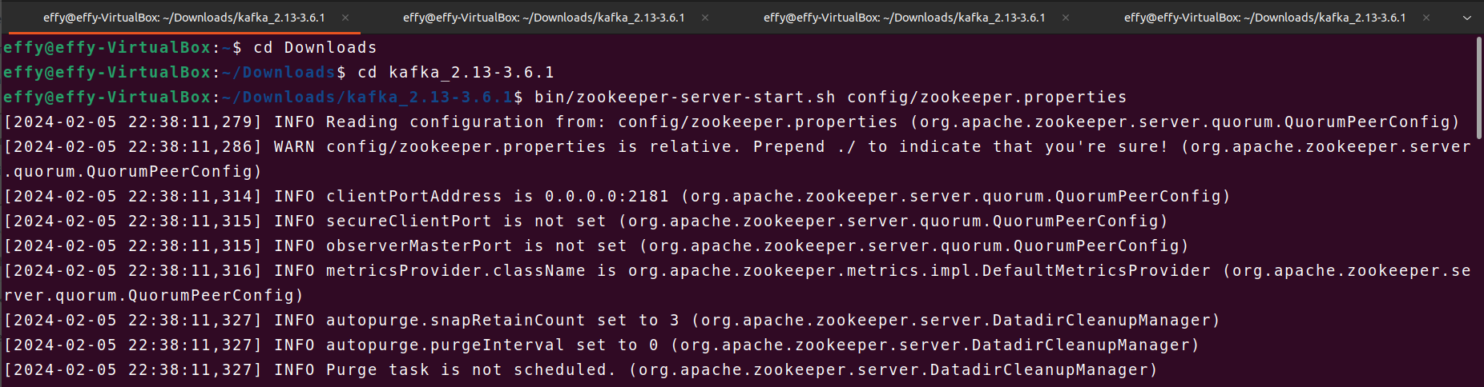

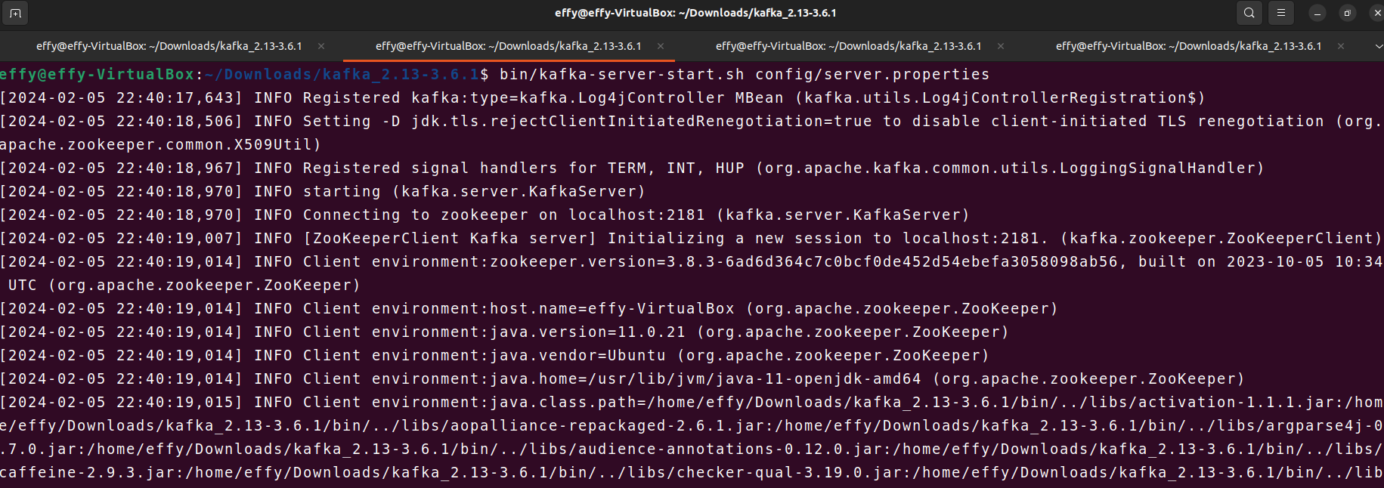

Python Code (Producer & Consumer):
The Python code for both the Kafka producer and consumer was structured and comprehensively commented, facilitating ease of understanding and maintenance.
- Kafka Producer:
  - producer.py was developed to generate synthetic weather data for Winnipeg and Vancouver at five-second intervals. The data adhered to predefined ranges for temperature, wind speed, and humidity for each city. This data was then written to the weather-data Kafka topic.

  - The script begins by importing necessary modules, including json for serialization, time for time-related operations, KafkaProducer from the kafka package for producing messages to Kafka, and random for generating random weather data. It defines a custom serializer function serializer() to serialize messages to JSON format before sending them to Kafka. The Kafka producer is initialized with the specified bootstrap servers and the custom serializer function. A generate_weather_data() function generates synthetic weather data for each city, adhering to predefined ranges for temperature, wind speed, and humidity. Within a main execution block, the script enters an infinite loop, producing weather data (city, temperature, wind_speed, humidity) for each city, sending it to the Kafka topic, and printing the produced data. It also logs the details to a producer.log file with the transmitted timestamp. A five-second delay is introduced between each iteration to simulate real-time streaming.

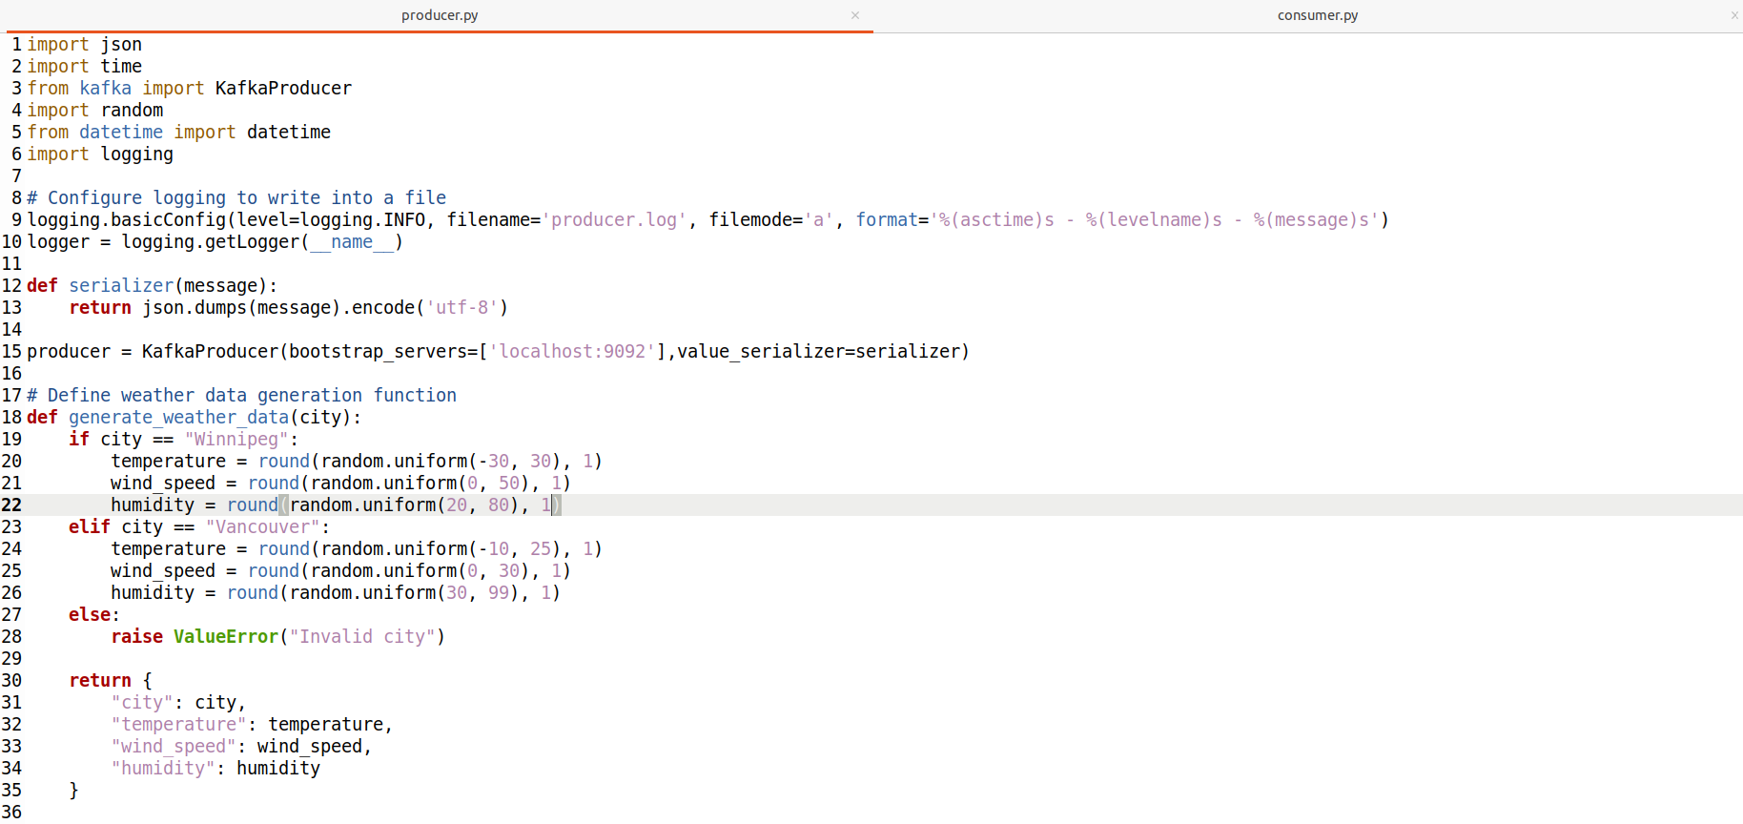
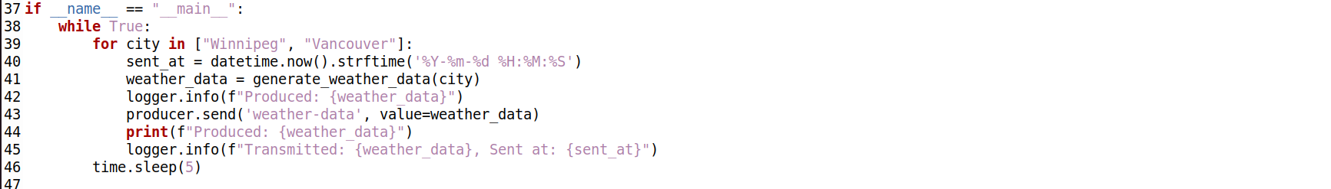

- Kafka Consumer:
  - Implemented in consumer.py, the consumer script subscribed to the weather-data topic, retrieved weather data messages, appended a timestamp to each event, and subsequently inserted the data into a PostgreSQL database table named weather_data.
  - This Python script functions as a Kafka consumer, designed to ingest weather data messages from the Kafka topic "weather-data" and persist them into a PostgreSQL database named "assignment6_DB". The initial segment of the script establishes the necessary imports, including json for JSON serialization, KafkaConsumer from the kafka package for Kafka message consumption, psycopg2 for PostgreSQL database interaction, and datetime for timestamp handling.
  - Script initializes the Kafka consumer with the specified configuration, ensuring it begins reading messages from the earliest available offset in the topic. The subsequent database setup involves connecting to the PostgreSQL DBMS, disconnecting any active sessions, dropping the existing "assignment6_DB" database if it exists, and subsequently creating a fresh instance of the database. Once the database is created, the script connects to it and proceeds to define a function, create_table(), responsible for creating the "weather_data" table within the database if it does not already exist.
  - insert_to_database() is defined to insert the consumed weather data messages into the "weather_data" table, appending a timestamp to each record. The script's main execution block first calls the create_table() function to ensure the table's existence and then enters a loop to consume weather data messages from Kafka. For each consumed message, the script creates the received_at timestamp, prints the data, and inserts it into the database using the insert_to_database() function. The script also updates the consumer.log file with the details.

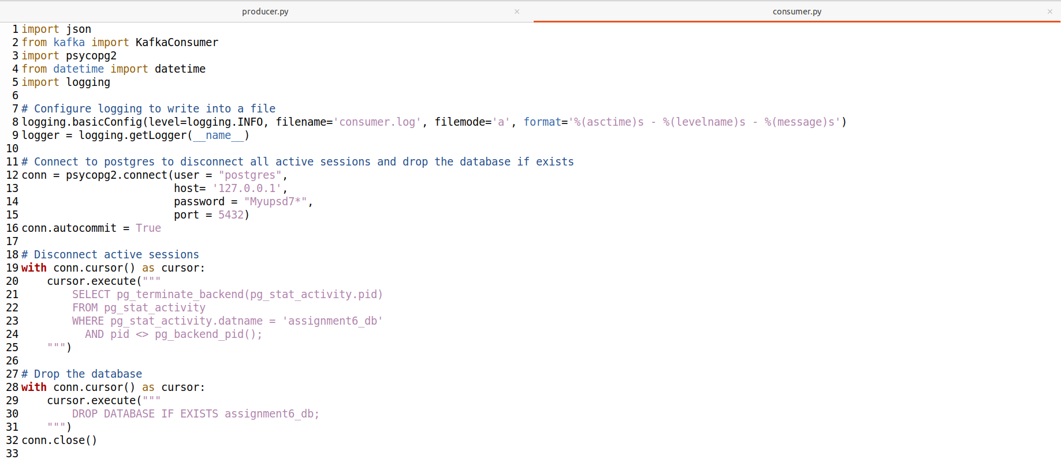
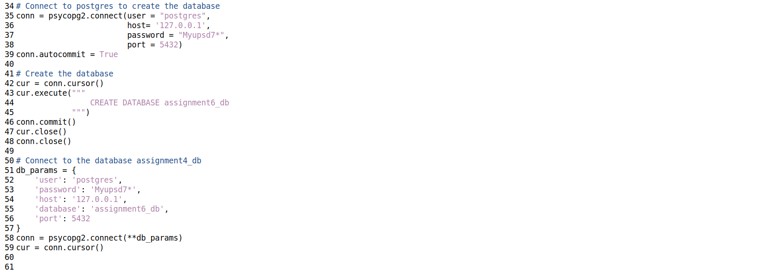
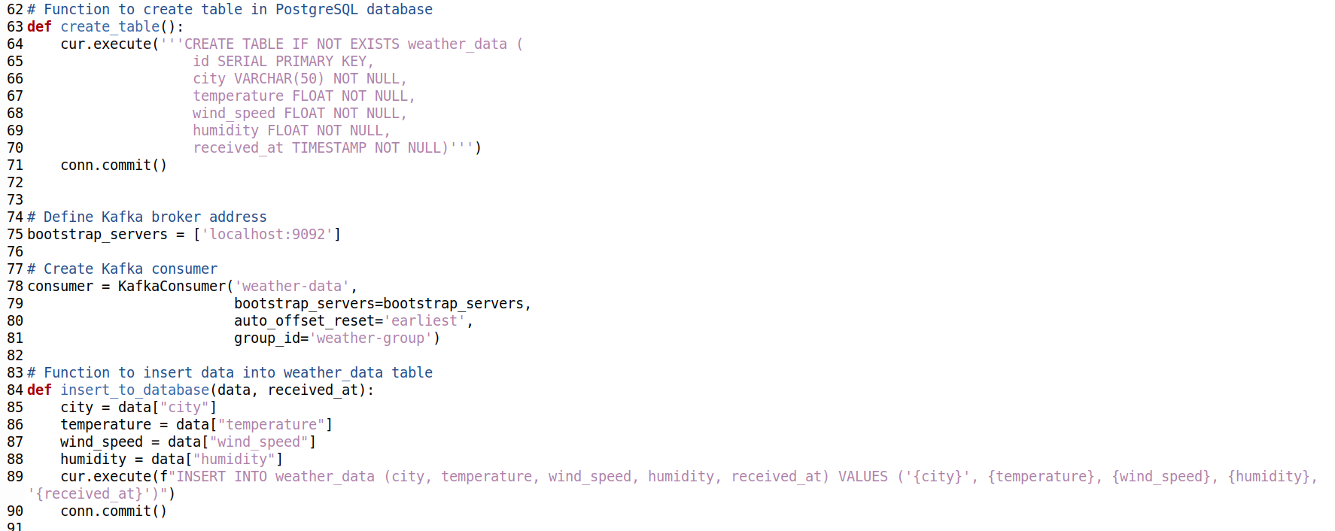

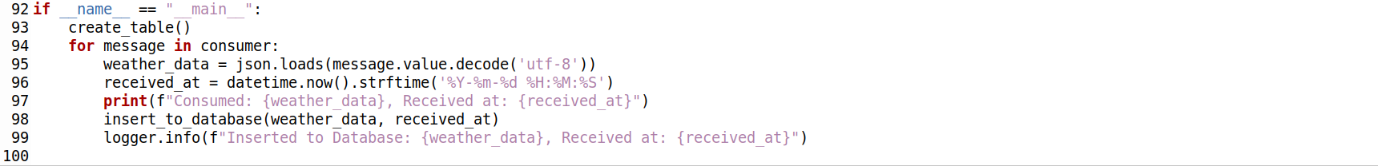
Run Kafka Producer

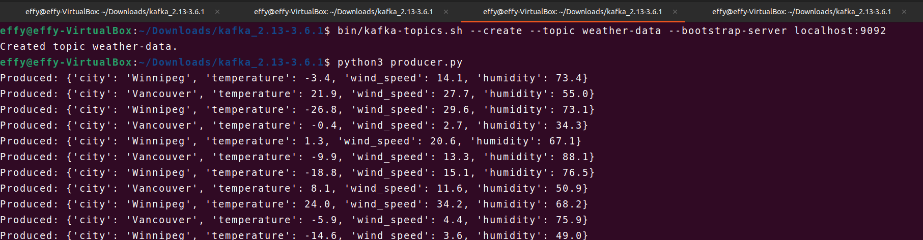

Producer Log file:

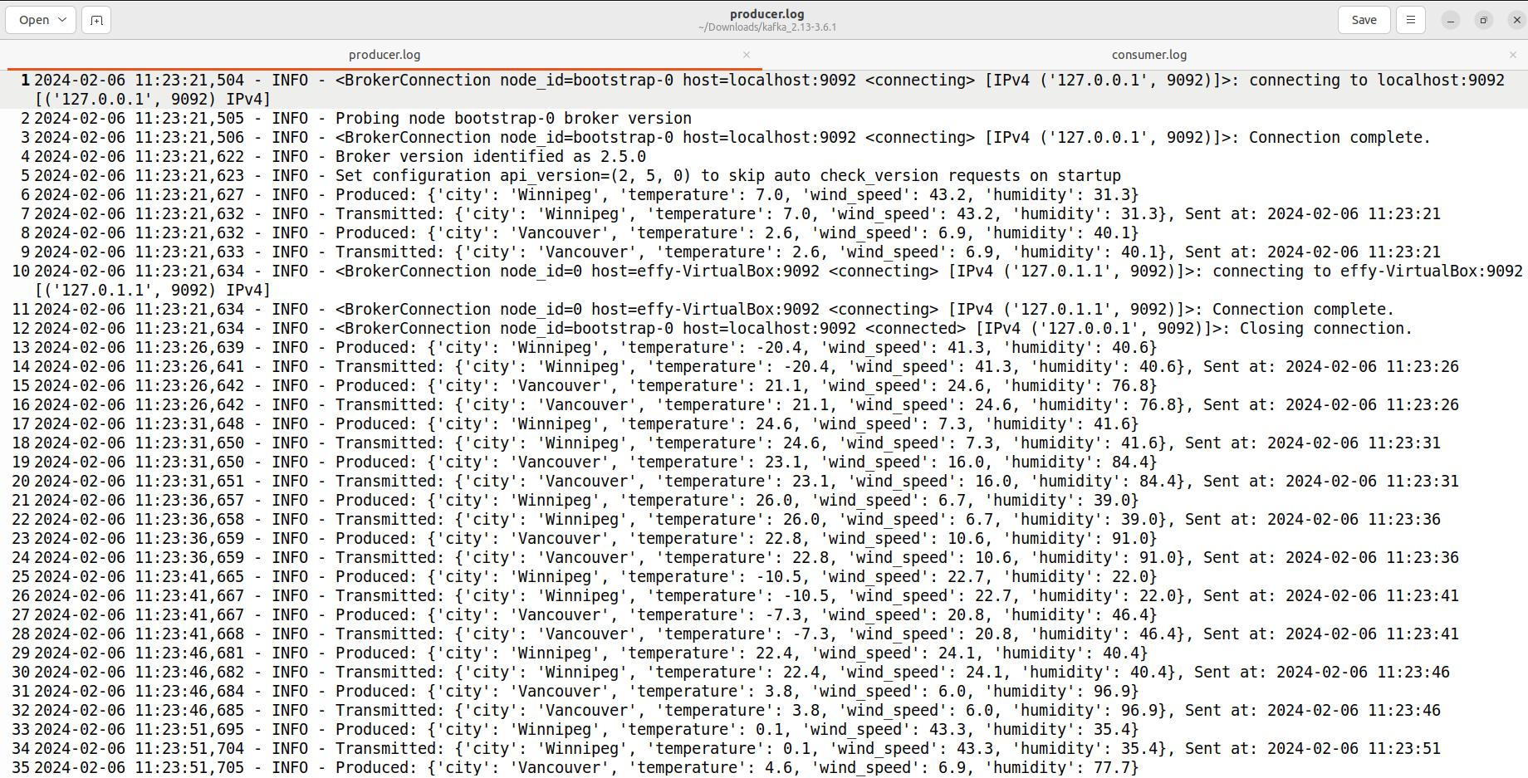
Run Kafka Consumer

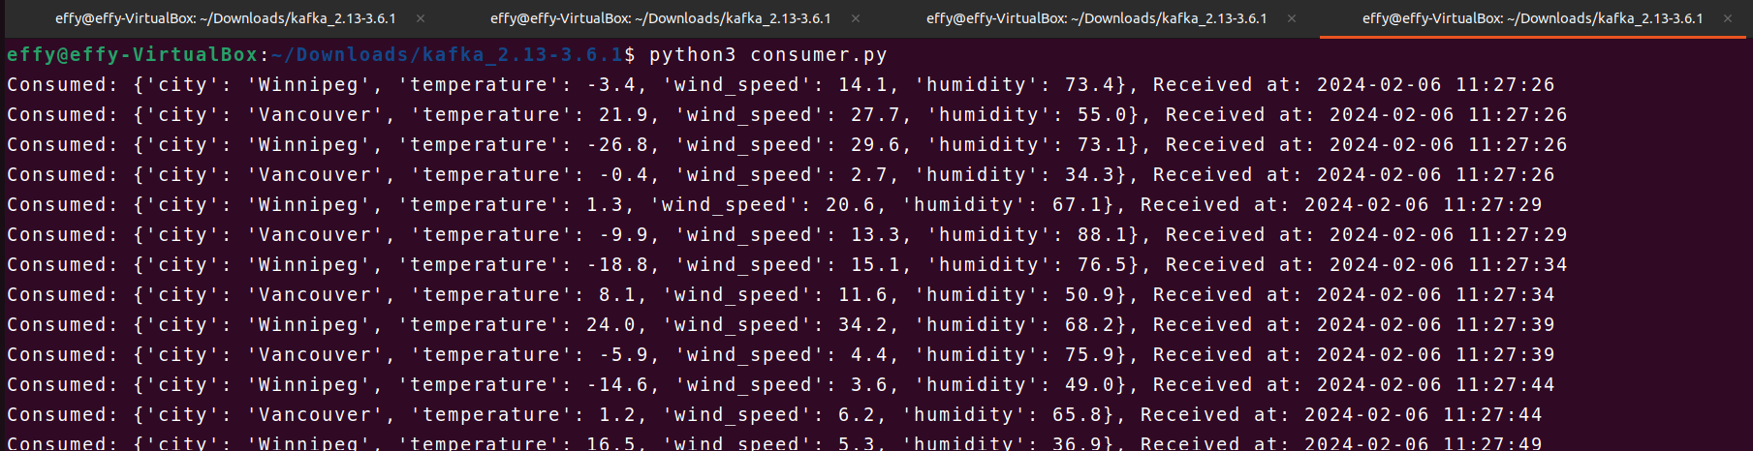

Consumer Log file:

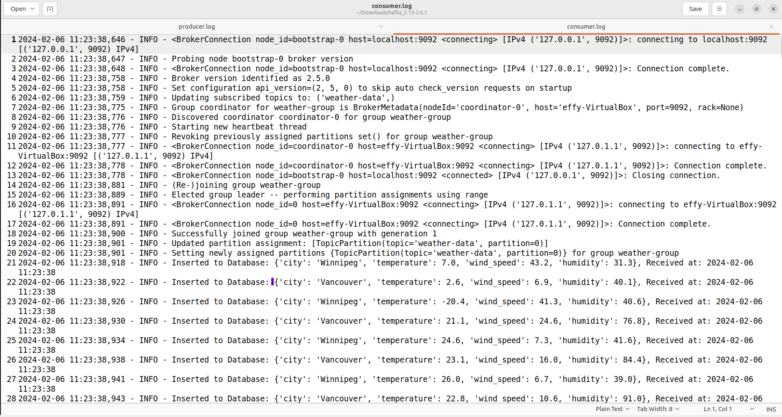

Stop Kafka Producer
- After about 10 minutes, stopped the producer by pressing Ctrl + C in the terminal where it's running.

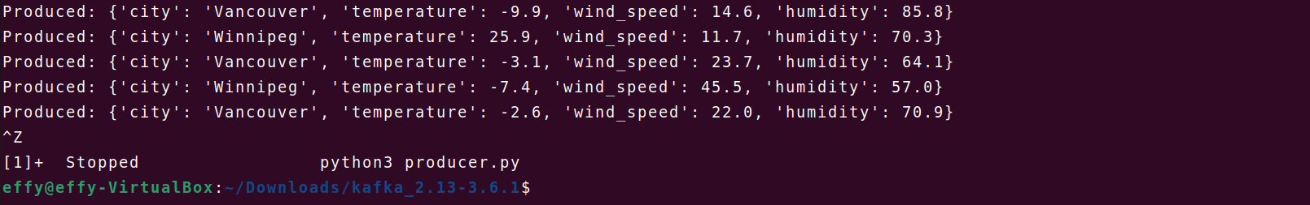

Verify Data in Database
- Verified that the data is loaded onto the database as per the requirements.

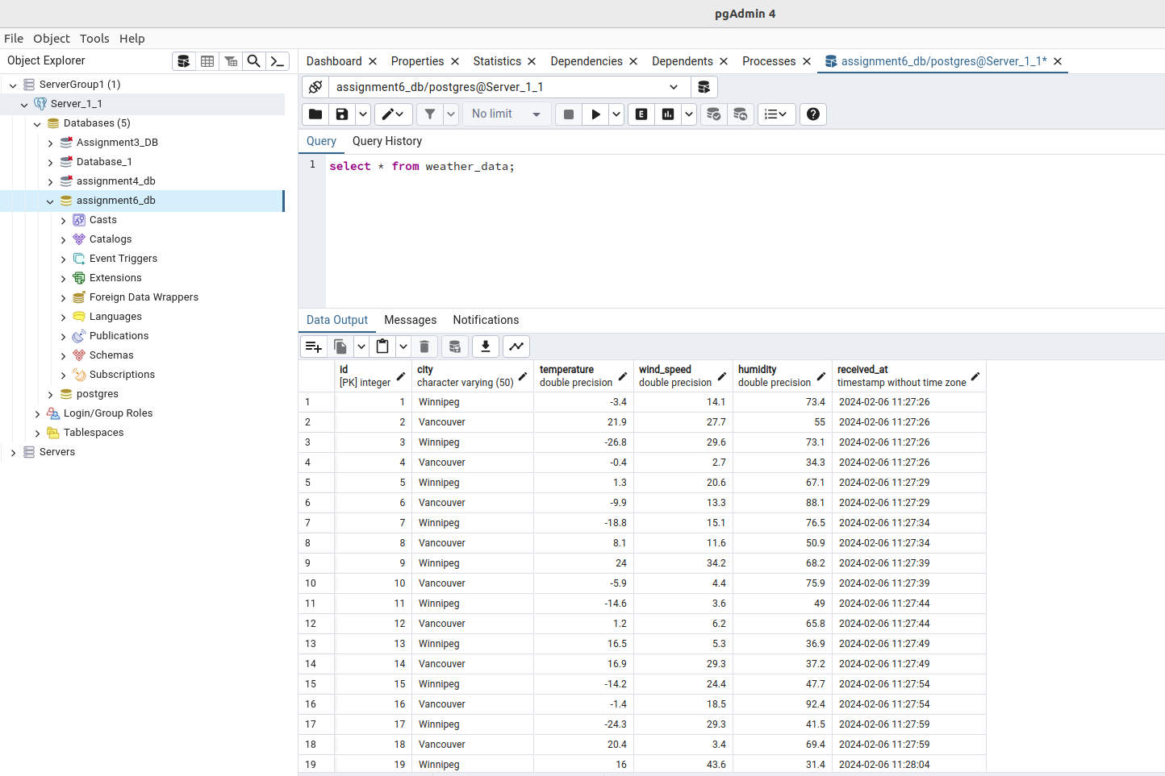

Stop Kafka and Zookeeper
- Stop all services by closing their respective terminals or using appropriate commands.

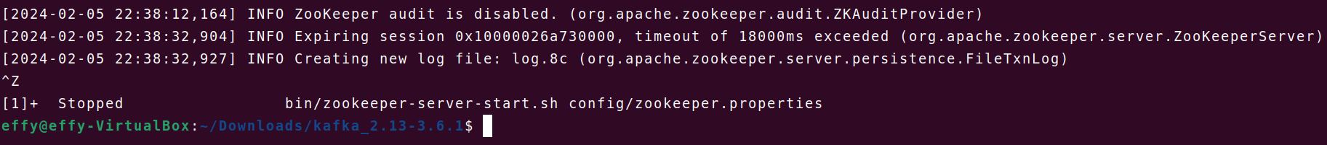

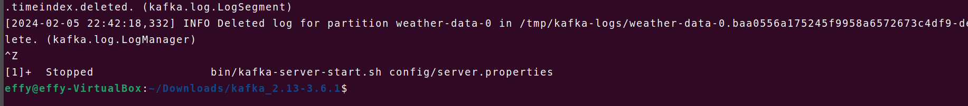

Overall Summary:

The project aimed to develop a system capable of live-streaming weather data for Winnipeg and Vancouver while storing this information in a PostgreSQL database. By designing Python scripts for Kafka producer and consumer, along with auxiliary functions for data generation and database interaction, the project demonstrated exemplary execution and adherence to requirements.

Throughout the project, Zookeeper and Kafka services were seamlessly initiated and maintained, ensuring uninterrupted operation of the data streaming pipeline. The Python code for both producer and consumer components was well-structured, thoroughly commented, and exhibited robust functionality. The Kafka producer efficiently generated synthetic weather data at five-second intervals, adhering to predefined ranges for temperature, wind speed, and humidity. This data was successfully written to the designated Kafka topic, facilitating smooth data ingestion into the pipeline.

On the consumer side, the script subscribed to the Kafka topic, retrieved weather data messages, appended timestamps, and persisted the information into the PostgreSQL database.

In conclusion, the "Weather-App" project exemplified the effective utilization of Apache Kafka for building a robust streaming data pipeline. The seamless integration of Kafka with PostgreSQL, coupled with well-organized Python code, underscore the reliability, scalability, and potential for future enhancements. Overall, the project achieved its objectives.

